Lab Task 3

Name : Nazish Ishfaq
ID : F2024332112
Subject : OS Lab
Department: Data science
Section : D1

Code:
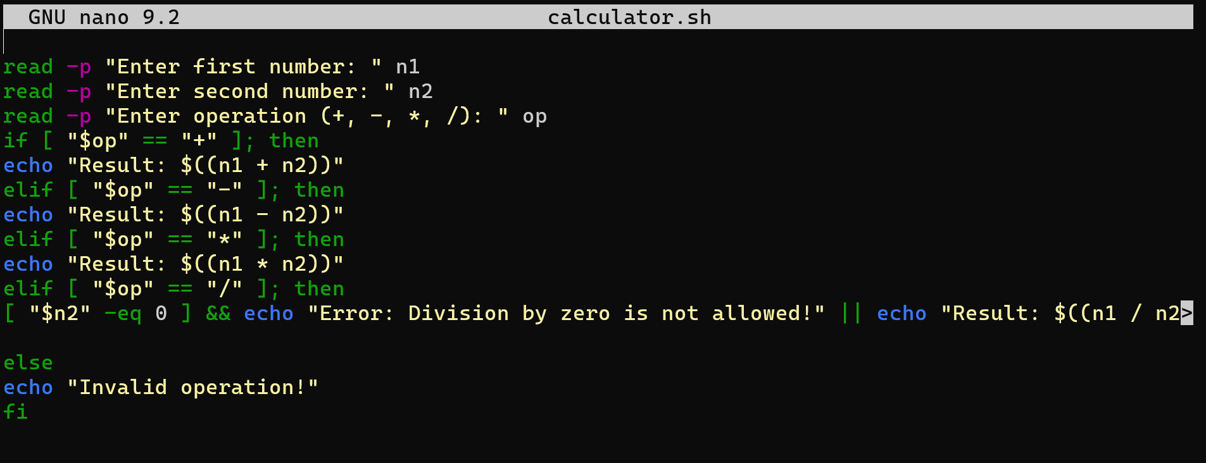
Output:


